Xiaoxu Na

Project 1 Due Date : 01/29/2019

Color model conversion:

write a program to convert RGB to HSV and LAB color space.

**>Run proj1_color.py.**

**>It will pop out three windows, which are of BGR, LAB, and HSV color space.**

**>Press ANY KEY to close all the windows popped.**

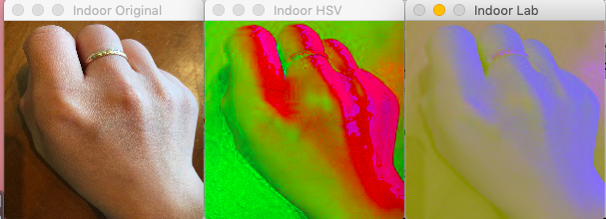

Image enhancement:

(From book Learning OpenCV 3 - COMPUTER VISION IN C++ WITH THE OPENCV LIBRARY, Page 404, exercise 2)

Before doing this exercise, please read ‘chapter13. Histograms and Templates’ in ‘Learning OpenCV 3 - COMPUTER VISION IN C++ WITH THE OPENCV LIBRARY’.

Take three images of a hand in each of the three lighting conditions (indoor environment, a shaded outdoor environment, and a sunlit outdoor environment.) Use cv::calcHist() to make an BGR histogram of the flesh color of one of the hands photographed indoors.

a. Try using just a few large bins (e.g., 2 per dimension), a medium number of bins (16 per dimension), and many bins (256 per dimension). Then run a matching routine (using all histogram matching methods) against the other indoor lighting images of hands. Describe what you find.

**>Run proj1_hist.py**

**>change hBins, sBins at the very beginning to 2, 16, 256**

**>Results shown in Console**

**The more bins, the more difference we found using different methods. As it can be seen, for method 0 (correlation) and method 2 (intersection), the higher score it gets, the more similar the two images are. However, for method 1 (Chi-square) and method 3 (Bhattacharyya), the higher score it gets, the more different the two images are. The results showed exactly correct that the indoor looked more like the sunlit image comparing with the shaded since the shaded had a different color tone of the hand, which looked whiter than the others.**

**hBins = sBins = 2**

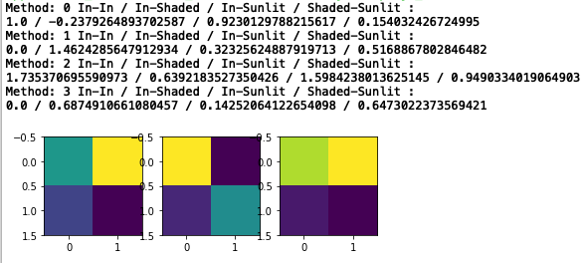

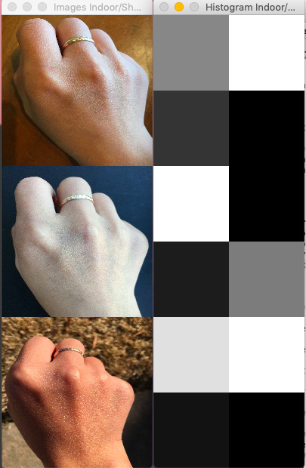

**hBins = sBins = 16**

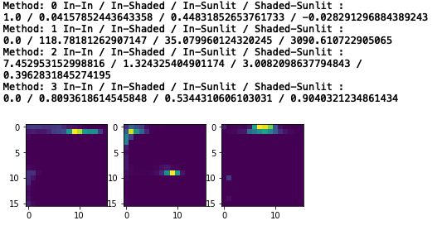

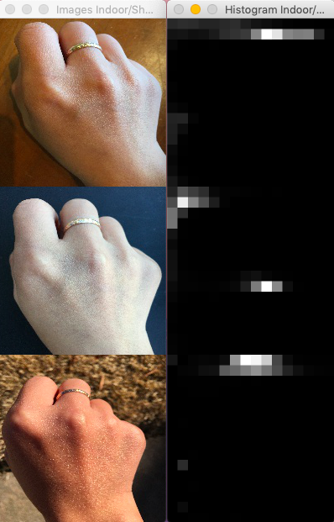

**hBins = sBins = 256**

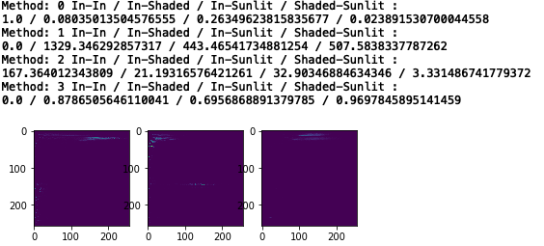

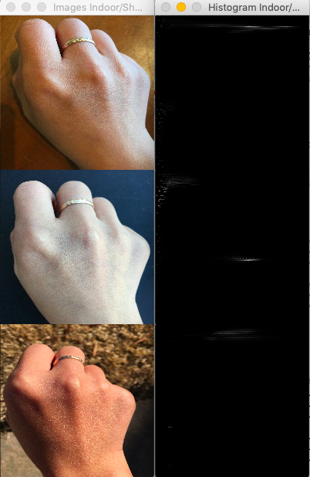

b. Now add 8 and then 32 bins per dimension and try matching across lighting conditions (train on indoor, test on outdoor). Describe the results.

**>Run proj1_hist.py**

**>change hBins, sBins at the very beginning to 8, 32**

**>Results shown in Console**

**hBins = sBins = 8**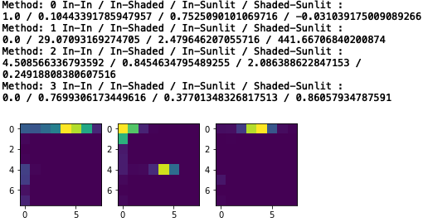

**hBins = sBins = 32**

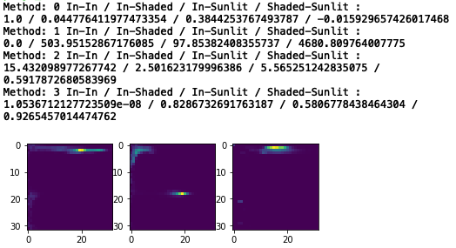

**>Run proj1_matching.py to identify the hand object in the three conditions**

**>Press ANY KEY to close all the windows.**

**The more bins we used, the more accurate we distinguished the hand from the background.**

**Bins = 8 for indoor**

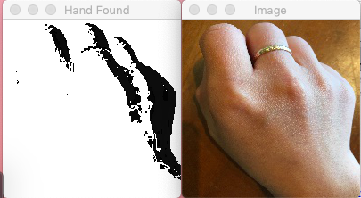

**Bins = 32 for indoor**

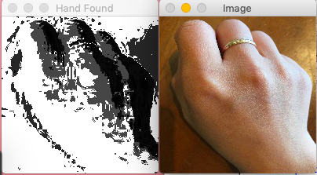

Reference

https://gaming.youtube.com/watch?v=udZDOzHE1Lo